|  |
| --- |
| Picture of beach with an accessible path through the sand. Wheelchair users and buggies can be seen on the sand at the bottom of the path. There is a sign in the bottom right corner of the picture which reads 'Beach Access Surface'. It includes an image of a mother pushing a buggy and a wheelchair symbol.  **Join us to share your thoughts**  At the end of 2017, DLR County Council announced:  **“€100,000 will be spent on improving accessibility on beaches in DLR”**  Beach users with disabilities, older people and young families are expected to benefit most.  **What do you think** needs to be prioritized as part of the project?  PUBLIC CONSULTATION:  Access to Beaches in DLR |
|  |



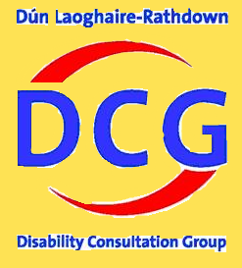

**When: Friday, April 27th @ 3- 5pm**

**Where: The Studio, the Lexicon Library, Dun Laoghaire**

**Let us know you’re coming:**

Email [lauraenglish@disability-federation.ie](mailto:lauraenglish@disability-federation.ie) or call 086 8206736