Tidy Districts Consultation 2021
Application Form

Tidy Districts 2021 includes a phone consultation, personalised report from an environmental specialist and supportive grant.
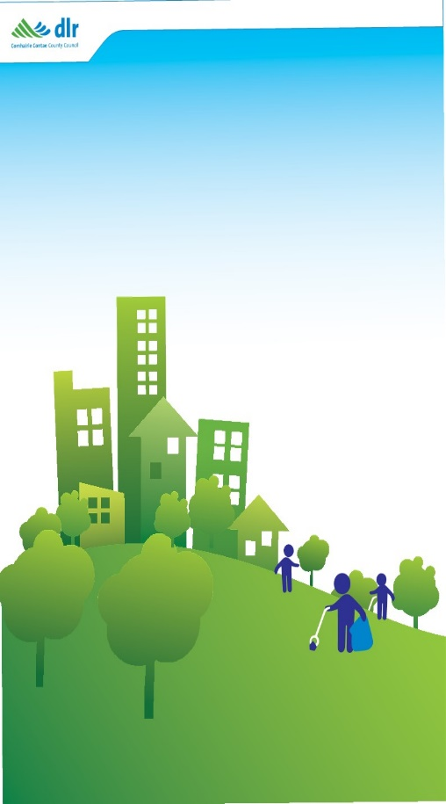
Please complete and return this application form to tidydistricts@dlrcoco.ie before 5pm on 28 May 2021.

Who can apply?
Applications are invited from residents’ associations, estate management groups, tidy district groups and tidy town groups within Dún Laoghaire-Rathdown.

What will the consultation involve?
This supportive consultation will include -
- A phone consultation with an environmental specialist to discuss your application form and any queries you may have in June (optional).
- The specialist will visit your area (June or July). Please note that the visit cannot involve in-person face-to-face contact.
- A personalised report will be produced and returned by September.
- A tidy district grant of €350 will be awarded to each participant group in September, to support actions arising from the consultation.

How do I apply?
Please complete this form and return it to TidyDistricts@dlrcoco.ie by 5pm on Friday the 28th of May 2021.
We will reply within three working days with an email to acknowledge your application and provide further details on the next steps.

Should you have any queries, please contact Environmental Awareness at TidyDistricts@dlrcoco.ie

Contact Details

Group Name

Group Email Address

Your Contact Name
Your Contact Email Address

Your Contact Phone
Your Contact Postal Address

Do we have your permission to share this form and your contact details above with the environmental consultant, for the purposes of this consultation and to enable direct contact*? Please state yes or no.

Please visit dlrcoco.ie (here) to view the Council’s GDPR policy

The specialist will phone your contact number for the consultation. Please outline any time preference you may have (e.g. lunch time only, do not call on a Friday, text first).

Would you like to subscribe to the dlr Environmental Awareness Quarterly Newsletter? Please list any email addresses you would like to add.

Please describe your area (e.g. the road names or house numbers that are included) or insert a map.

Overall appearance – please outline anything you’d like to highlight or any questions you may have.

Landscaping, planting and nature – please outline anything you’d like to highlight or questions you may have.

Litter and graffiti – please outline anything you’d like to highlight questions you may have.

Do you have any other information or questions that you would like to share?

Please complete and return the following form by 28 May 2021 by email to tidydistricts@dlrcoco.ie.

