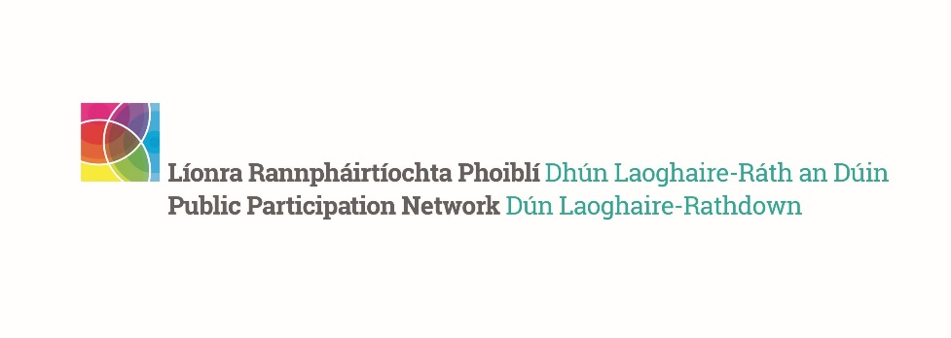
DLR PPN Autumn Networking Meeting 2023
__________________________________________________

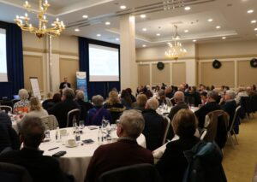 | 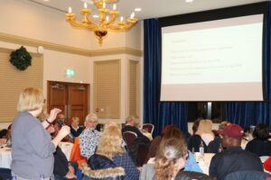 | 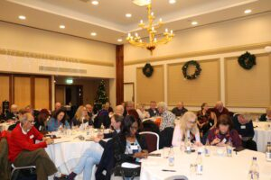
The DLR PPN Autumn Plenary Meeting took place on the 23rd of November in the Royal Marine Hotel, Dun Laoghaire. We were delighted to welcome 80 participants on the night, who gave their feedback about the first DLR PPN Five Year Plan 2024-2029.
The evening opened with a brief time for networking for participants, followed by a short presentation about the PPN, for the benefit of newer members who might not be yet fully acquainted with what the PPN does and does not do (see below).

About the PPN
Public Participation Networks were established through the Local Government Act in 2014. Their aim serve as the independent networks of community, voluntary, social inclusion and environmental organisations, active in all Local Authority Areas (31 in ROI).
- DLR PPN is independent from the dlr County Council.
- We have more than 600 member groups active in DLR.
- There are two staff members, hosted by Southside Partnership.
- The yearly budget is around €120,000.
- The Secretariat manages and oversees the budget, workplan, staff and activities.

All our activities reflect the aims of the PPN:
- To facilitate communication between community groups and the Local Authority
- To enable representatives from the community to sit on various decision-making committees within the Local Authority
- To increase capacity and good practices within the local community by providing relevant training
- To act as an information hub, keeping community groups informed of relevant initiatives and opportunities in DLR
- To support the community as needed (Community Stakeholder Forum)

What we don’t do:
- We do not provide funding, sponsorship or loans
- We do not manage or have access to the funding set in place by the Council
- We do not have direct influence in executive or operational decisions made by the Council with respect to their service (e.g. parks maintenance)
- We are not political
- We do not run the dlr Times printed publication
- We are not directly involved in the drafting of any of the Council local plans, Annual Service Plans, Budget

Five Year Plan Consultation
Following the brief presentation about the PPN’s aims and activities, Finbarr Fitzpatrick of Business Improvement Solutions led the participants in a consultation exercise which sought to explore the following themes:
- What does the PPN represent for members
- What works well
- Opportunities facilitated by the PPN
- Awareness/Understanding of the work of the PPN
- Barriers to participation

The consultation to develop the Five Year Plan will involve the following:
- Start With Why – the what, how and why of DLR PPN: a method of revisiting core purpose, values and activities
- Future Mapping – define a future state for DLR PPN
- Strategic Priorities – identifying the 5/6 most important decisions/challenges/developments for DLR PPN over next 5 years
- SWOT – Plan vs Reality: interactive exercise exploring assets, challenges, opportunities and risks that may enable or prevent the plan being delivered

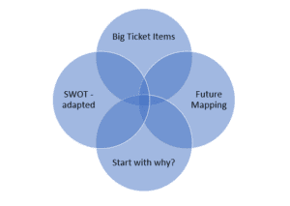

Participants were asked to fill in a short anonymous survey, which will also be shared with the wider membership.

Next steps for the consultation
- A consultation survey will be circulated to all our membership to capture as many views as possible – beginning of December 2023.
- The draft Five Year Plan will be circulated for feedback in late January 2024 and with a view to ratify the final draft at the Spring Networking Meeting in April 2024.
The final part of the evening was an open call to the participants to share news or initiatives that might be of interest to the community. The meeting closed at 8.50pm.

