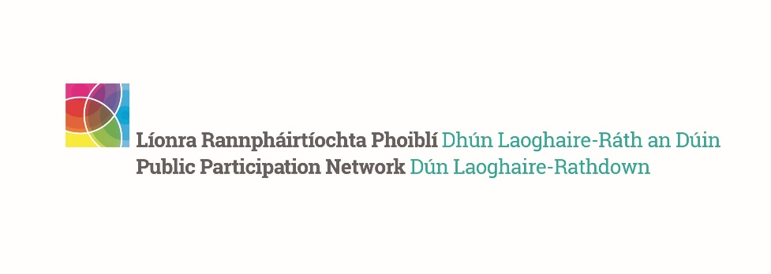
Building Connections Networking Event and Launch of the DLR PPN Strategic Plan 2024-2028
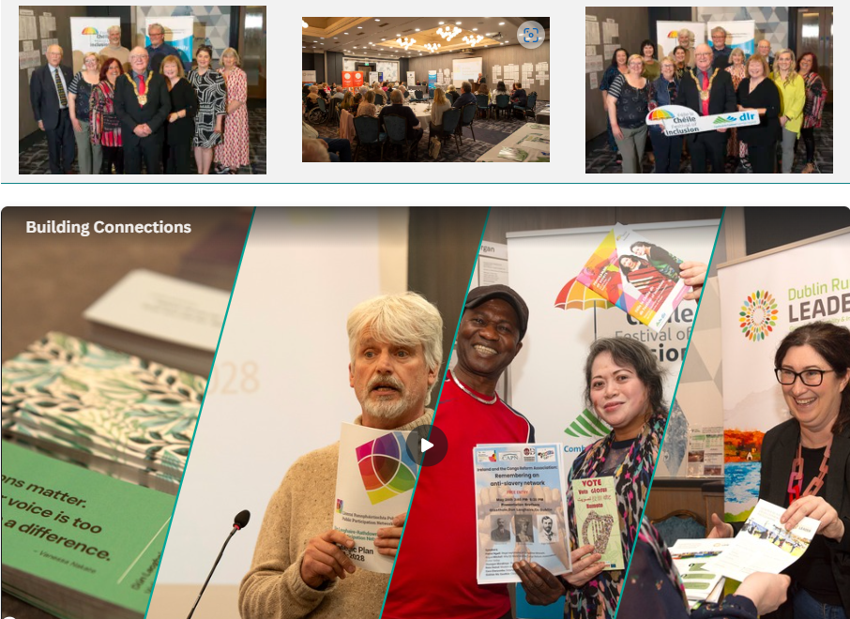
In keeping with the theme of dlr Festival of Inclusion 2024 – ‘Building Friendships in the Community’, DLR PPN and dlr County Council hosted the Building Connections: Community Networking on the 15th of May, from 7 to 9 pm, in the Talbot Hotel, Stillorgan Park.
We were delighted to welcome more than 120 participants who explored the many social inclusion, community, older people’s, environmental, youth, disability, resident associations, sports & activities, migrant communities groups operating across Dun Laoghaire-Rathdown. The event was officially opened by An Cathaoirleach, Councillor Denis O’Callaghan, and also included the launch of our Five Year plan 2024-2028 by the DLR PPN Secretariat – please see the programme outline below. To read the DLR PPN Strategic Plan, please click here.

Featured initiatives, organisations and projects:
Funding
– dlr County Council Community Grants information stand;
– Dublin Rural Leader funding information stand.
dlr County Council Initiatives
– Healthy Age-Friendly Homes Programme information stand;
– dlr Sports Partnership information stand;
– Community Climate Action initiatives information stand.
Community organisations
– Adult Education Service South East information stand;
– DLR Social Prescribing for Health & Wellbeing information stand;
– dlr Integration Forum information stand; – DLR Volunteer Centre information stand;
– Women’s Collective DLR information stand;
– DLR County Childcare;
– Family Resource Centres DLR information stand.
DLR Public Participation Network
– A print-out of all our member groups in each electoral area were displayed;
– DLR PPN Five Year Plan 2024-2028 information stand.
Posters of member groups
– An A4 poster for the 35 DLR PPN member group who wished to be promoted.
On arrival, all participants received a ‘Networking Card’ and a pen at the door to encourage networking with each other and writing down contact details.
The schedule for the evening included:
- 7.00pm to 7.30pm – Arrival and networking
- 7.05pm – Food served – selection of finger food, sandwiches, wraps, dessert, tea & coffee
- 7.30 pm – 7.55pm – Speeches – Tony McCarthy, DLR PPN Secretariat member introduced the speakers:
  - An Cathaoirleach, Cllr Dennis O’Callaghan
  - Siobhan Nic Gaoithin, dlr Age-Friendly Programme Manager & Social Inclusion Officer
  - Gavin Harte – DLR PPN Secretariat, Launch of the DLR PPN Strategic Plan 2024-2028
  - Simone Sav – DLR PPN Network Manager
- 7.55pm – 9.00pm – Networking time
- 9.00pm – Close of evening
This event was part of the dlr Festival of Inclusion 2024 and you can see the list of events at this link.
To read the DLR PPN Strategic Plan 2024 -2028, please click here.

