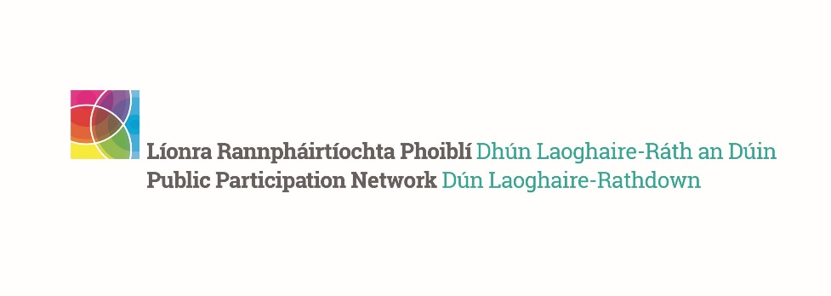
DLR PPN Focus on Funding Training Week
A week of events all about funding for the DLR community
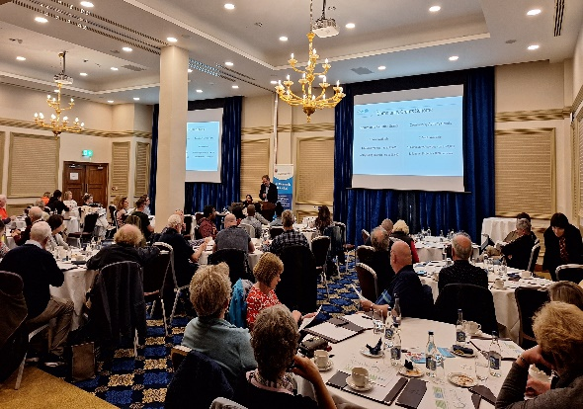 | 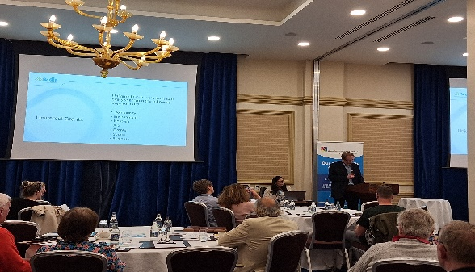
Rationale for the initiative
During the consultation process for the DLR PPN Strategic Plan 2024-2028, we heard from a number of our stakeholders that one of the most appreciated supports provided by the PPN is information, signposting and training about funding. For this reason, we put together a week of training with the theme of 'Focus on Funding' from the 10th to the 13th of June 2024.

Training topics
1) Monday 10 June 7-9 pm Sources of Funding with Evelyn Fitzpatrick
Location: Dundrum Pastoral Centre, Main St, Dundrum (In-Person Event)
This seminar provides an opportunity to identify the challenges and the most common mistakes applicants make. Participants should come away with a better understanding of appropriate language and wording to help better make the case for their grant application.
2) Tuesday 11 June 7-9 pm All About dlr County Grants
Location: Royal Marine Hotel (In-Person Event) Find out about the different funding opportunities provided by dlr County Council and how to apply.
3) Wednesday 12 June 2024 11 am - Clan Credo Information on the funding supports they provide to Community & Voluntary groups (Zoom 45mins)
4) Thursday 13 June 11 am - Change X - Information on their online funding platform and projects they support (Zoom 30min)
Training sessions summary
- The sessions were held both in person and online and we are delighted that more than 100 participants joined.
- Excellent feedback from the participants.
- The training materials and slides were circulated to everyone who registered.
- Thank you to all who joined the DLR PPN Focus on Funding week and to all the speakers and trainers.
- Further training on funding will be delivered starting September 2024, as part of a collaboration with Dublin City PPN - details to follow shortly.

