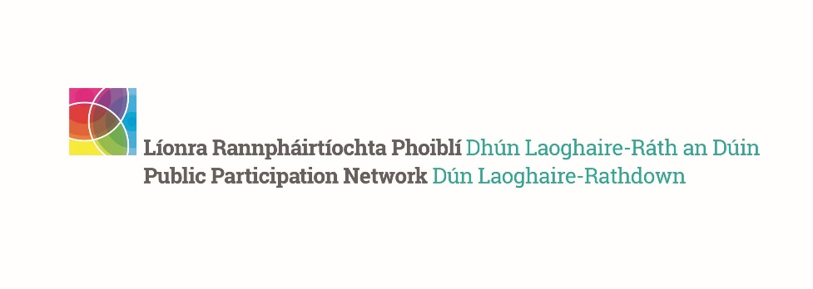
PPN National Conference 2023 Report
__________________________________________________

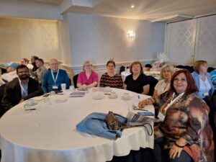
- Two-day conference brought representatives from across Ireland together to discuss citizen engagement
- Public Participation Networks (PPNs) give local communities a say in local government decisions
- Over 18,500 groups across Ireland helping to ‘Build a better future’ through their involvement

Minister of State with responsibility for Community Development, Charities and Integration, Joe O’Brien, T.D. attended the fifth National Public Participation Network Conference held in the Arklow Bay Hotel, Wicklow.
Addressing the delegates, Minister O’Brien spoke about the important contribution PPNs make:
“PPNs are key partners in local decision making and are increasingly becoming the ‘go-to’ for community engagement. After all, who knows better than the citizens at the heart of our communities what is best for our communities and how to work together to achieve positive results.”
The two-day conference event was hosted by Wicklow Public Participation Network, in conjunction with Wicklow County Council, the Department of Rural and Community Development and the National PPN Advisory Group. It was attended by a wide range of PPN stakeholders, including volunteer representatives from PPNs across the country, local authority officials, and elected representatives.
Minister O’Brien highlighted the value of the work done by PPNs in promoting citizen engagement and participative democracy:
“PPNs give communities access to decision-makers in a very unique way. They provide a voice for communities in local decision-making and create strong relationships between stakeholders.”
The Minister continued:
“Hundreds of PPN representatives currently sit on boards and committees of local decision-making bodies across the country, contributing to decisions on housing, climate, transport, migrant integration, community health and wellbeing, policing and many more. Your local knowledge is key to understanding and delivering information, support and practical solutions to issues in your areas. You are bringing the community voice to the table to help ensure no one is left behind.”
The conference, which was attended by over 200 delegates, had a varied and interesting agenda of workshops and presentations on, for example, collaborative projects between PPNs and Local Authorities, and innovative community schemes initiated by PPNs around the country. It also included site trips to a number of locations around Wicklow, where delegates met with local community organisations that are involved in and empowered by Wicklow PPN.
Concluding the Minister said:
“From my own perspective and that of my Department, one clear message I would like you all to take away from this conference is that we will continue our support of PPNs into the future.
“You are all, as our awareness campaign said, building a better future and better communities for everyone.”
Dun Laoghaire Rathdown Participation Network participated with one of the largest number of representatives, including members of the Secretariat: Aileen Eglington, Kay Gleeson, Tony McCarthy, Sharon Perry and Siby Sebastian and DLR PPN staff Colette Downing and Simone Sav. We were delighted to be joined by Therese Langan, Director of Services of the Community and Cultural Development in the dlr County Council and Mary Ruane, Chief Officer of DLR LCDC & Senior Executive Officer, Community and Cultural Development Department, Dún Laoghaire - Rathdown County Council.

