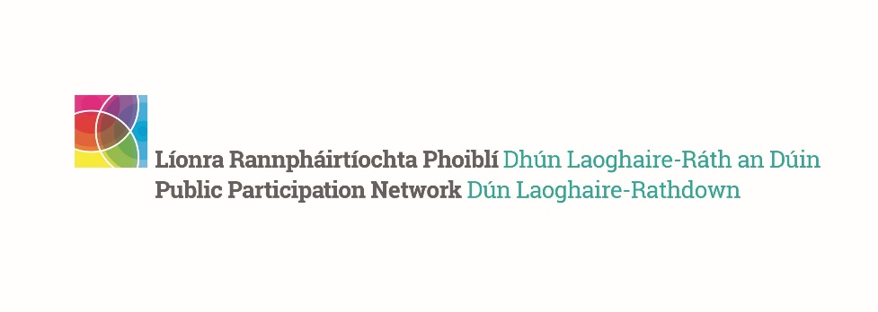
DLR PPN Representatives’ Meeting February 2024
_____________________________________________

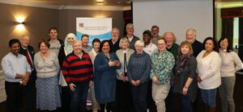 | 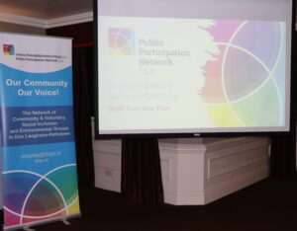

The DLR PPN Representatives' Networking Meeting took place on Thursday, the 22nd of February, from 7.oo in the Talbot Hotel. The first notification went out in December 2023, with several reminders sent to all current representatives in January and February 2024. The Agenda is captured below.
AGENDA
7.00- 7.15pm – Networking
7.15 – 8.00 – Brief presentation of the DLR PPN Five Year Plan and discussion
8.00pm – Dinner and activity feedback
9.15pm – Close of meeting

Meeting Summary:
- A total of 20 representatives and Secretariat members were present.
- The presentation of the Draft DLR PPN Five Year Plan and discussion was facilitated by Simone Sav.
- The outline of the presentation is available below.
- The feedback will be shared with the consultant and the wider membership.
- The Meeting concluded at 9.15pm, with a word of THANKS to all participants, especially the Strategic Policy Committee representatives whose activity comes to an end before the Local Elections.

Summary of Draft DLR PPN Five Year Plan Presentation:

Who we have consulted with so far
- Facilitated discussion with DLR PPN staff, focus group discussion with the DLR PPN Secretariat.
- Facilitated open forum discussion with members as part of the DLR PPN Plenary meeting on November 23rd, 2023.
- DLR PPN membership survey on-line and in hard copy completed by 114 members.
- Ongoing liaison with the DLR PPN Manager and Development worker throughout the process.
- A desk review of existing information and data to develop a deeper understanding of the work of DLR PPN.
- Thematic analysis of all data generated through the consultation.

Structure of the Draft Plan
- Section 1 – Methodology
- Section Two provides further detail on DLR PPN, outlining the key roles, functions, and governance structures. It includes an overview of the prevailing strategic and policy context reflecting, the UN Sustainable Development Goals, the DLR PPN Community Wellbeing statement, the DLR Local Economic and Community Plan and the DLR County Development Plan.
- Section Three is framed around a thematic analysis of the data generated from the stakeholder consultations which assists with the compilation of a Strengths, Weaknesses, Opportunities and Threats (SWOT) analysis.
- Section Four sets out DLR PPN’S 2024-2029 strategic plan with objectives, success indicators and key actions. The mission, vision, and values to guide DLR PPN’s work over the next five years are presented.

The DLR Context
The Small Area (SA) population data (2022 Census) identified that 11.1% of the DLR population was categorised as ‘disadvantaged’, accounting for over 26,000 persons. This cohort of people are in 84 of the 760 Small Areas the comprise the DLRLDATF area despite the data at the Electoral Division (ED) level reflecting an overwhelmingly affluent profile. SA analysis enables the exploration of deprivation in areas of 90 houses. The SAs where the greatest disadvantage presents are in the Loughlinstown, Ballybrack, Sallynoggin and Ballinteer areas.
The nature of marginalised disadvantaged communities in DLR, surrounded as they are by significant relative affluence, makes disadvantage hidden for targeted services, funding, and policies.
Indicator – Census 2016 vs Census 2022 | 2016 | 2022
Population | 218,018 | 233,860
Population at Work | 95,925 | 106,548
Labour Force Participation Rate | 58% | 60.2%
Unemployment Rate | 7.4% | 6.2%
% of Population aged 15+ with Education to Primary Level only | 6.6% | 2.54%
% of Population aged 15+ with Education to Upper Secondary | 32.4% | 33.39%
% of Population aged 15+ with Education to Third Level | 57.7% | 58.31%
One Parent Family Ratio | 15.4% | 14.1
% Local Authority Housing | 5.9% | 6.16%
% of Population from the Traveller Community | 0.2% | 0.18%
% of Population from New Communities | 11.6% | 17.13%

What we heard
- What DLR PPN Represents
- A useful resource for community groups was the most popular response followed by providing information and training to local groups. Further insights into what members found useful about DLR PPN can be deduced from respondent’s comments.
- “It provides an outlet for specialist theme-based groups such as environmental and maritime to integrate into the wider D.L.R. community.”
- “Dependable avenue for advocacy between the council and community, providing great networking opportunities.”
- “A trusted source of information with very competent and helpful people running it.”
- “Our thanks to the PPN for what it already does and hopefully will have the funding and resources to be able to continue into the future.”
2. Most Useful Updates | Rating
Funding Opportunities | 1
Training Opportunities | 2
Local events organised by DLR PPN community groups | 3
Information sessions on upcoming funding, consultations, initiatives. | 4
Consultation initiatives on a local level | 5
Local events organised by organisations in DLR, in Public Bodies, and/or not for profits | 6
Climate Action Initiatives | 7
Consultation initiatives on a national level | 8
3. Participation
- 67% attended a plenary meeting
- 39% attended an information event advertised by DLR PPN
- 33% availed of funding opportunities
- 32% engaging in a community event promoted through the ezine.
4. Networking
- 65% of respondents indicated that they would know a few other PPN members
- 29% did not know any other PPN members. Greater connection between members would enhance collaboration and joint working
5. Understanding of the PPN
- 43% good understanding of the structure and remit of the DLR PPN
- 39% having a vague understanding.
6. Engaging with the DLR PPN Representatives
- 46% of respondents felt that some members but not all would be aware of the role of Strategic Policy Committees
41% feeling that members don’t understand the function of SPCs.
- 29% of respondents have discussed local policy with their DLR PPN representatives
29% reporting not knowing DLR PPN representatives or how to contact them.
54% of respondents have never discussed local policy with their DLR PPN representatives
7. Barriers to Participation
Time constraints due to work and family life alongside other volunteer roles were identified as the most significant barriers to enhanced PPN participation such as becoming a DLR PPN Representative or Secretariat member. Not fully understanding the commitment involved was cited as the next most prevailing challenge. The third wasn’t necessarily a barrier rather a statement on motivation for involvement with respondents indicating that they were only interested in the networking, training and the information provided by DLR PPN.
8. Communication
There was near unanimous consensus among respondents that DPR PPN’s communication was very effective. They found the PPN events, information on funding and grants, the newsletter and general e-mail correspondence and interaction with members very beneficial.
9. DLR PPN & Community Groups
In response to a question on how DLR PPN can enhance the skills needed to run effective community and voluntary groups in DLR, training in governance, digital skills, the environment, how the council works, building capacity of groups to fundraise, lobby and advocate, and facilitating engagement with elected representatives were the most prominent responses. Mentoring and sharing resources, knowledge and expertise among member groups were initiatives that respondents felt DLR PPN could facilitate.

Strategic Priorities
- Strategic Priority 1 – Governance & Operations
Future Statement – DLR PPN has robust Governance & Operations
- Strategic Priority 2 – Participation & Representation
Future Statement – DLR PPN has equitably facilitated the participation and representation of communities
- Strategic Priority 3 – Capacity Building
Future Statement – DLR PPN has strengthened the capacity of member groups to positively impact the wellbeing their community
- Strategic Priority 4 – Information & Communication
Future Statement – DLR PPN provided relevant and accessible information and communicated effectively with all stakeholders

- To read the DLR PPN Draft Plan, please click here
- To give your feedback, please click here
- or send us an email at enquiries@dlrppn.ie
- or post us a quick note to DLR PPN, Old Post Office, Main Street, Blackrock, Co. Dublin
The deadline for responses: Monday, 11th March 2024

