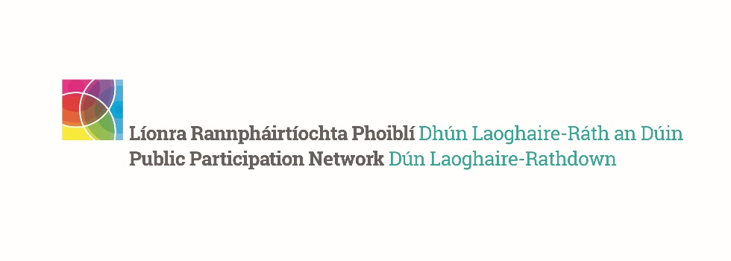
DLR PPN Representatives Summer Networking Meeting Report
__________________________________________________

The Secretariat’s aim for the DLR PPN Representatives having reestablished a sense of connection post covid is to plan forward in respect of the council elections in 2024 and the establishment of new SPCs that will result.
Anne Colgan, founding DLR PPN secretariat member was invited to speak at our June meeting and share her experience and thoughts about being a PPN Representative, her approach was a practical one.
Anne’s first point was that as SPCs meet 4 times a year for 2 hours, a total of 8 hours is available to influence policy, therefore, you need to be realistic, strategic and to have a plan. She spoke of the importance of networking, sharing and working together with a shared vision. To be prepared for meetings by reading the information you are provided with and by researching. Engaging with your fellow committee reps prior to the meeting to discuss your approach.
One of her key points was “Use the Machinery on Offer”, as reps you have the right to put a written question to the SPC you should use this right. You are entitled to follow up.
Reps should be aware of the council’s Annual Service Delivery Plan and the role of the Corporate Policy Committee which coordinates and links the work of the various SPCs and acts as a forum where policy decisions affecting the entire Council can be agreed for recommendation to the full Council.
Anne also spoke of the importance of reporting on your activities as your input is not necessarily recorded in the meeting minutes, yet you have given of your time to research, obtain the views of the membership and attend meetings. By reporting on your activities you are reporting back to the membership you represent and your fellow representatives are made aware of what is happening in the other decision-making committees.
The second half of the meeting involved a round table discussion. Representatives and Secretariat members were divided into their 3 pillar groupings to discuss issues such as training needs, new representative onboarding, and how best to seek and represent the views of the membership. The representatives shared their experiences of attending committee meetings and discussed how to work together.

DLR PPN Representatives 2nd Quarter 2023 Report.
It is very important that our representatives report on their activities, please complete the report whether or not you attended a meeting. You can complete your report here.

So far this year we have:
- Re-established connection.
- Established a Representatives Network and will have our next meeting on 12th October 2023, please save the date.
- Reps Buddy System has been established; the secretariat members will act as a point of contact for representatives from their pillar group. They are there for existing representatives and for new representatives, especially when finding their feet.
- Representatives Area on the new website, which will contain contact details of the representatives who have consented to have them published in this password-protected area, this should enable networking and communication between representatives. The password to this area will be sent to those who have consented to share their contact details in the coming week.
- It is intended to populate the area with any information that you feel is relevant and useful. This will take some time and hopefully in the near future we will have a Forum feature for you to use.
Still to do
- Linkage groups
The next step in our process of reconnecting is to find ways where representatives can as such seek the opinions of and report back to the membership they represent. One of the things that we discussed was the re-establishment of linkage groups at the meeting it was also explained that for a linkage group to be considered active (by the Department of Rural and Community Development, our main funder) it must meet three times a year.
Maintaining working linkage groups is a nationwide PPN issue and not exclusive to DLR PPN.
Linkage Groups will be on the September Secretariat Meeting Agenda, and hopefully, they will come up with a workable solution that will be achievable within the resources available.

- Forward Planning
Our next DLR PPN Representatives Meeting will take place on 12 October 2023, in the Talbot Hotel Stillorgan.
Our next Plenary Meeting will take place on the evening of Thursday 23 November 2023.
These are two dates that we ask you to save in your diaries.

