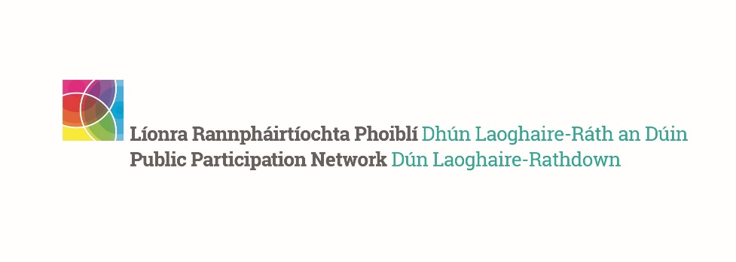
DLR PPN Representatives October 2023 Meeting Report
__________________________________________________

The meeting took place on the 12th of October, in the Talbot Hotel, Stillorgan Road. A total of 16 representatives attended. The meeting agenda included
- A brief presentation about the PPN national Secretariat structure – speaker Kay Gleeson, DLR PPN Secretariat member.
- A workshop on how to improve the PPN structure and function – facilitator Gavin Harte, DLR PPN Secretariat member.

Summary of the findings
- A key learning from our PPN Reps workshop on the 12th of October reveals we have healthy community-centred approach to engagement that is advocating for greater identification and empowerment of local community activists to expand on our activities.
- Effective communication, visibility strategies, and administrative support from the Secretariat are key to improving engagement processes.
- Recognition of peoples contributions, inclusive outreach, and strategic networking are suggested as solutions to foster long-term commitment.
- The strongest themes emphasise the importance of connecting PPN activities to peoples interests, aspirations, and life experiences, directly involving communities, and thereby promoting a democratic ethos as a foundation for enhancing individual participation.
- The feedback highlights a holistic approach to community engagement, emphasising the need for both top-down support from the PPN Secretariat and staff as well as fostering and supporting grassroots initiatives.
- There is a repeating focus on local relevance, personal relationships, as well as the effective use of communication channels for a more engaged and democratic PPN.

Inspiring Community Role Models:
Participants identified a diverse array of local leaders and organizations as role models, highlighting the value of passionate individuals and groups who drive community action. This includes active retirement groups, resident associations, and local business leaders who cultivate a sense of neighborhood unity. The mention of venerable figures, such as the founder of Shankill Day Care Centre, emphasises the enduring impact of dedicated community service.

Overcoming Barriers to Engagement:
The feedback suggested that the PPN can play a pivotal role in reducing barriers by fostering a welcoming environment that respects time constraints and economic pressures. Suggested measures include providing clear communication, easing formalities, and addressing language barriers. Emphasising inclusivity and support for those who may feel overwhelmed or disillusioned can also encourage broader participation.

Creative Outreach Tools:
Creative engagement strategies proposed by participants include organising neighborhood events, leveraging social media platforms, and utilising storytelling to share the PPN’s work. These approaches are suggested to be coupled with personal touches, such as inviting people to share their ideas, and hosting inclusive events that highlight the relevance of the PPN's work to the community.

Fostering Long-Term Commitment:
To enhance long-term engagement, suggestions include the rotation of committee members to avoid burnout, regular communication, and the establishment of a strategic group to oversee progress. Transparency and accountability, such as sharing annual reports and detailed project plans, are also seen as crucial. Participants believe that continuous evaluation and feedback loops can maintain momentum and commitment.

Engaging People in Community Action:
The participants underscored the importance of identifying and supporting community leaders as catalysts for involvement. Emphasising local relevance and leveraging media to bridge the rural divide are seen as key to reaching out to broader demographics. Inspirational events, skill-sharing, and tapping into the vast network of local clubs and associations are proposed to enhance engagement. Additionally, there is a call for direct outreach to understand community concerns and needs, suggesting that personalisation of issues could make them more attractive and thus encourage participation.

Role of Secretariat and Staff in Facilitating Engagement:
The Secretariat and staff are viewed as instrumental in distributing resources, such as hard copy guides, and utilising digital platforms like ezines more effectively. Simplifying the administrative burden of meetings, improving visibility through notice boards and kiosks, and curating newsletters are suggested to keep the community informed and engaged. The creation of a services directory and the promotion of topic-related discussions are recommended to foster a sense of ownership and direct contribution among community members.

SOME ADDITIONAL THEMES

Cultivating a Supportive Environment:
Participants propose creating more visibility for PPN efforts and successes, such as showcasing effective change like that seen with the Shankill Day Care Centre. Encouraging PPN representatives to actively participate in local events and to share the merits of the PPN reflects a strategy of community pride and word-of-mouth advocacy. Policy influence is another area where the Secretariat can play a role, by providing training and advice on how to increase the impact of PPN representatives.

Promoting Inclusivity and Recognition:
There is an emphasis on inclusivity, with suggestions to explore who is missing from the conversation and how to involve them, perhaps through a more targeted invitation strategy. Recognition of engagement through awards and the promotion of success stories are advocated to motivate and appreciate active members.

Strategic Communication and Networking:
Consistent communication through local media and newsletters, alongside fostering local political and socio-economic involvement, are seen as fundamental. Hosting meet-and-greets in casual settings like cafés could break down barriers to entry. A strategy that respects Pareto’s principle (80/20 rule) may help in prioritising efforts that yield the most significant outcomes.

Long-Term Engagement and Policy Influence:
To ensure long-term commitment, the suggestions include regular updates to a knowledge base, organising clinics for topic-specific discussions, and providing networking opportunities to help structure community proposals. Promoting climate action campaigns could also serve as a rallying point for sustained community interest and activism.

