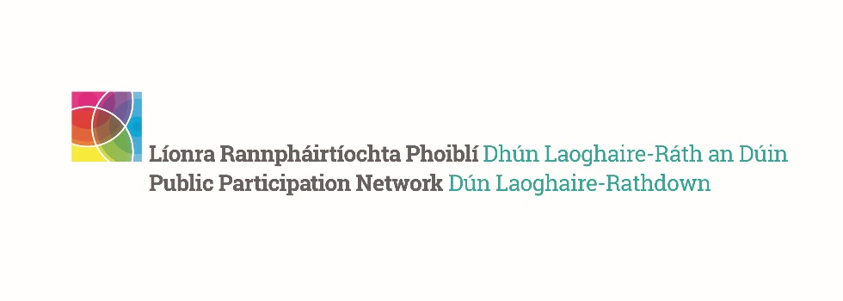
DLR PPN Spring Networking Meeting 2024
__________________________________________________

The DLR PPN Spring Networking Meeting (Plenary) took place on the 11th of April in the Talbot Hotel, Stillorgan Road. The agenda for the evening was as per below:

Spring Networking meeting
AGENDA
LOCATION: | The Talbot Hotel, Stillorgan
Date: | Thursday 11 April 2024
7.00 - 7.10 pm – Registration
7.10 - 7.45 pm - Networking and Refreshments (hot finger food, tea and coffee)
7.45pm - Welcome and start of Network meeting
7.50 - 8.30pm - DLR PPN Reports and Ratification
-------------------2023 Annual Report
------------------DLR PPN 2024 Workplan and Budget
-------------------DLR PPN New 5 Year Plan
8.30 - 8.40pm - Become a DLR PPN Representative
8.40 pm – AOB
8.45pm - Close of meeting
More than 65 groups registered to attend, and there were 50 participants during the evening. The voting representative from each full member group attending was given voting cards upon registration to ratify the reports and plans for 2024.
For the first time, the DLR PPN published the Directory of members and everyone who attended was encouraged to get to know the groups in their area and network with those present on the night. The online Member's Directory is available at this link. We would ask all members to let us know if the details for their group are correct, as there is the possibility that some details need updating since the first registration was submitted.
Following a presentation from the DLR PPN Network Manager, and several Question & Answers opportunities, all the documents were ratified:
- DLR PPN Annual Impact Report 2023
- Workplan and Budget 2024
- Five Year Plan 2024-2028
For any questions about the above, please contact us at enquiries@dlrppn.ie

